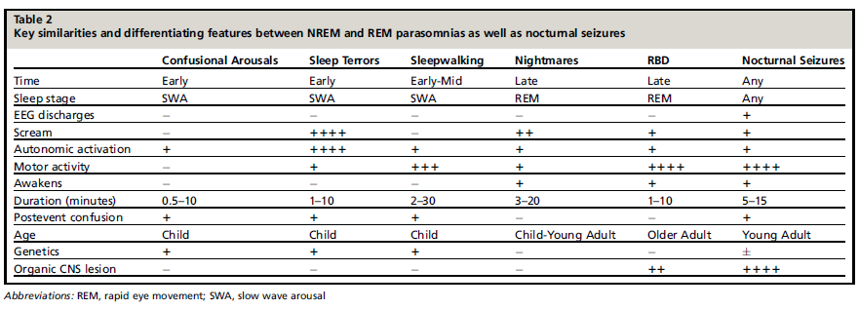
RBD
Rapid eye movement sleep Behavior Disorder

Source:
Avidan AY, Kaplish N.
The Parasomnias: Epidemilogy, Clinical
Features, and Diagnostic Approach.
Clin Chest Med 31 (2010) 353-370.

